Name: _______________________________________________
Foundation Unit 18 topic test
Date:
Time: 35 minutes
Total marks available: 30
Total marks achieved: ______

Questions
Q1.
(a) Work out 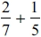
...........................................................
(2)
(b) Work out 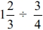
...........................................................
(2)
(Total for question = 4 marks)

Q2.
Work out 3¹⁄₃÷ 4¾

..............................................................................................................................................
(Total for Question is 2 marks)

Q3.
Work out 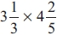
Give your answer as a mixed number in its simplest form.
...........................................................
(Total for question = 3 marks)

Q4.
Write these numbers in order of size.
Start with the smallest number.
0.0034 × 10⁵ 34 × 10⁻⁵ −3.4 × 10⁻³ 3.4 × 10⁴ 34 × 10²
.............................................................................................................................................
.............................................................................................................................................
(Total for Question is 3 marks)

Q5.
(a) Write down the reciprocal of 5
...........................................................
(1)
(b) Evaluate 3⁻²
...........................................................
(1)
(c) Calculate 9×10⁴×3×10³
Give your answer in standard form.
...........................................................
(2)
(Total for Question is 4 marks)

Q6.
Work out the reciprocal of 0.125
...........................................................
(Total for question is 1 mark)

Q7.
Work out the value of (7.5 × 10⁴) × (2.5 × 10³)
Give your answer in standard form.
...........................................................
(Total for Question is 2 marks)

Q8.
(a) Write 8.2 × 10⁵ as an ordinary number.
..............................................................................................................................................
(1)
(b) Write 0.000 376 in standard form.
..............................................................................................................................................
(1)
(c) Work out the value of (2.3 × 10¹²) ÷ (4.6 × 10³)
Give your answer in standard form.

..............................................................................................................................................
(2)
(Total for Question is 4 marks)

Q9.
Work out (2.5 × 10⁹) ÷ (5 × 10³).
Give your answer in standard form.

..............................................................................................................................................
(Total for Question is 2 marks)

Q10.
Work out 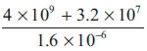
Give your answer in standard form.

..............................................................................................................................................
(Total for Question is 2 marks)

Q11.
* One sheet of paper is 9 × 10^{–3} cm thick.
Mark wants to put 500 sheets of paper into the paper tray of his printer.
The paper tray is 4 cm deep.
Is the paper tray deep enough for 500 sheets of paper?
You must explain your answer.

(Total for Question is 3 marks)

Q1.
No Examiner's Report available for this question

Q2.
This question was not well done with less than one in five candidates scoring any marks. The question was often either not attempted or an incorrect answer appeared on the answer line without any working shown in the space provided. Many candidates could not deal with or ignored the whole number parts in their calculations. Candidates working with decimals were given credit provided they carried out their working with sufficient accuracy. Many candidates lost marks here because they rounded prematurely. It is perhaps surprising to report that few candidates seemed to use a calculator to help them to complete the question or to check their answers.

Q3.
Many students could write the mixed numbers as improper fractions but then errors were made either in the multiplications or they omitted to change the improper fractions back to a mixed number.

Q4.
Most students tried to convert the given numbers as ordinary numbers and tended to be successful in this by converting at least 3 correctly which enabled them to score 2 method marks. However a lot of jumbled working was seen with many numbers written with 2 decimal points in the original decimal position and the final position. Credit for correct conversions could not be awarded in this situation. The most common error was to write 34 × 10⁻⁵ as 0.000034

Q5.
In part (a) many candidates did not know the meaning of the word 'reciprocal'. A variety of incorrect answers were seen with the most common being 25.
Part (b) was poorly answered. The most common incorrect answers were −9 and 0.03. Some candidates with the right idea failed to evaluate 3⁻² and gave the answer as
In part (c) Many candidates were able to gain one mark for evaluating 9×10⁴ × 3 × 10³ as 270 000 000 or as 27 × 10⁷. The difficulty for many was changing their answer to standard form. Many thought 27 × 10⁷ was in standard form and failed to do the final step. Candidates who first converted the numbers in the question to ordinary numbers often ended up with too many or too few zeros. Some evaluated 9×3 incorrectly.

Q6.
No Examiner's Report available for this question

Q7.
There was usually some evidence of the correct calculation being performed, but frequent errors in writing the answer correctly as required. The most common error was in writing the answer as 18.75 x 10⁷. A few candidates attempted to add the given numbers rather than multiply.

Q8.
This question on standard form gave a good range of marks. In part (a) most candidates were able to change a number written in standard form into an ordinary number but this reduced in part (b) to about a third when a number smaller than 1 had to be written in standard form. The division of two numbers that were written in standard form was poorly understood, with only a few candidates giving the fully correct answer and a few more gained 1 mark, usually for writing 0.5 × 10⁹ or 500,000,000 or even establishing 2.3 ÷ 4.6 × 10^{12 – 3}, but the very large majority who gained no marks usually failed to realise, due to this being a non-calculator paper, that 2.3 ÷ 4.6 was 0.5 and many thought the answer was 2 or 2.2.

Q9.
Candidates had great difficulty with division even where they used the common strategy of rewriting the calculation using ordinary numbers. Few dealt with the integers and powers of 10 separately but where they did do so, the errors 2.5/5=2 and 5/2.5 were seen. Although the question asked candidates to give their answer in standard form, 0.5 × 10⁶ was often seen along with an incorrect final step giving 5 × 10⁷

Q10.
Many correct answers were seen, usually without any intermediate working. Those who didn't get the correct answer often gained one mark for showing the digits 252 (2.52 × 10³ was a common wrong answer) or for working out the numerator as 4 032 000 000. Many candidates, though, made hard work of this question which could have been done easily with the correct use of a calculator. Many converted the values to ordinary numbers to do the calculation, often resulting in an answer not given in standard form or causing them to lose their way. Errors were frequently made in the evaluation of the numerator with many candidates failing to understand the place value implications of the different powers of 10.

Q11.
Most candidates made a good attempt at this question. Their approach was usually to find the total thickness of the 500 sheets of paper and compare this with the depth of the paper tray. This was often done successfully with a clear statement made in conclusion. A common error was to write 9 × 10⁻³ either as 0.0009 or as 0.09. Candidates who had previously shown the product 500 × 9 × 10⁻³ had already gained some credit and could score a further communication mark but candidates who had just written 0.0009 or 0.09 could not access these marks. Few candidates used the alternative approach of working out the thickness of each sheet of paper if exactly 500 could be stored in the tray and then comparing their answer with the thickness of a sheet of paper as stated in the question.

Mark Scheme
Q1.
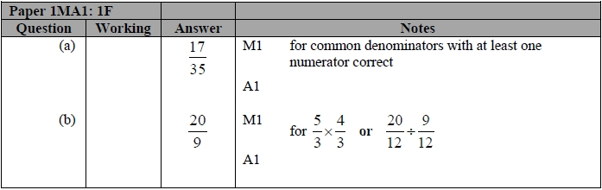

Q2.
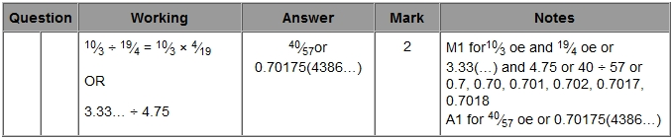

Q3.
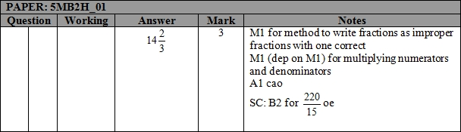

Q4.
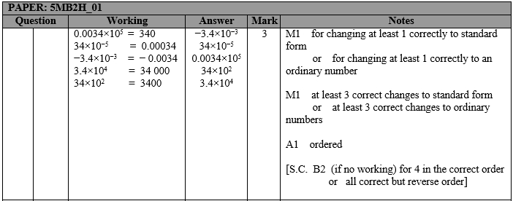

Q5.
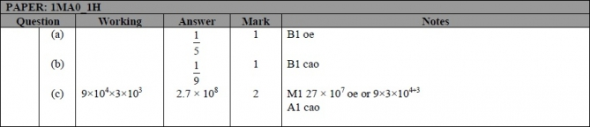

Q6.
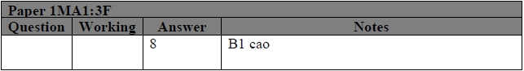

Q7.
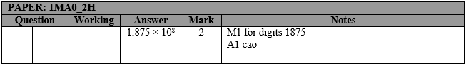

Q8.
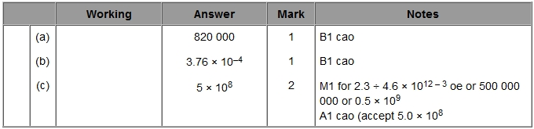

Q9.
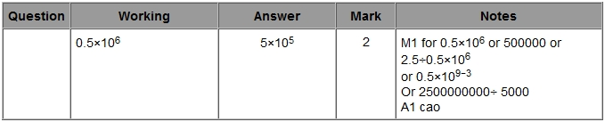

Q10.
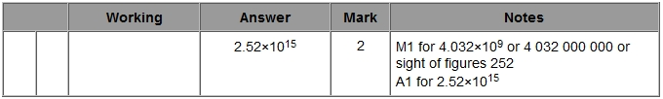

Q11.
